**MID-TERM QUIZ**

**Summer 2017**

**Course:** CEWP 459 PHP PROGRAMMING WITH MYSQL - LEVEL I

**Instructor:** Brendan Wood

**Time:** 3 Hours (Given July 25, 2017 @ 7PM)

|  |  |
| --- | --- |
| **Student Information** | |
| Family Name | Gamgo |
| Given Name | Josiane |
| Student ID | 40002047 |

**Instructions**

1. Please use the supplied DOC file to enter your answers (as a form).
2. Please only use Lab computers, no personal computers due to compatibility problems.
3. Save your work often. Also save a copy for your files.
4. The exam supervisor will answer questions regarding possible exam errors, but cannot help with the questions themselves, even if bribed.
5. Good luck

|  |  |  |  |
| --- | --- | --- | --- |
| **Section** | **Topic** | **Marks** | **Score** |
| **1** | Theoretical questions | 10 | /10 |
| **2** | Programming tasks | 20 | /20 |

**SECTION 1, Theoretical QUESTIONS** (1 point each)

*Time you should spend on this: Less than 60 minutes.*

Please provide an answer to the following questions. Important: Assume the person reading your answer has very basic PHP and programming knowledge.

There may be several questions in one line, be attentive to the question and completely answer the question.

1. Explain what htmlentities() does in PHP.

It outputs the html code as is .

1. A] What is hinting? B] And what is a very important reason we hint? C] What types of things can be hinted?

A.Hinting is not declaring/ specifiying the type of a parameter in a function. B. Allow the user to hide the logic behind the code . C. We can hint Classes, interfaces and arrays

1. What is wrong with the following code, and how do we fix it? (without putting $a in the parameter list of displayUppercase().

$a = "Charles";

function displayUppercase()

{

echo strtoupper($a);

}

Scope is the problem . function displayUpperCase(){global $a; echo $a;}

1. Explain what the following line of code does (in the context of how a form works).

$preference =

isset($_GET['foodPreference']) ? $_GET[' foodPreference '] : “n.a.”;

It assign the value of the $_GET[‘foodPreference’] to $preference if the $_Get variable exist , otherwise it assigne “n.a.” to $preference.

1. Code a switch statement that evaluates a number $age and sets $cost (for a bus ticket) depending on age. Rules are:

18-25, student, $1.50.

26-64, adult, $3.00.

65-∞, senior, $1.00.

Anything else sets $cost to null.

The code starts with:

$age = $_GET[‘age’]; $cost = 0;

Please complete the code:

$age = $_GET[‘age’]; $cost=0;Switch(true){case ($age<=25 && $age>=18): setcost(1.50) break; case($age<=64 && $age>=26): setcost(3.00);case($age>65) setcost(1) break; default: setcost(null) break;} function setcost($a){echo “$”.$a;} slide 48 , class1 (Switch with Ranges)

1. Explain “pass by reference” using a function, and how we accomplish this with PHP.

$a=3; function addtwo(&$a){ return $a+2 ;} function addtwo($a){ return $a+2;}. Does not make a copy of the variable before it goes to the function.

1. What is the difference between include, include_once, require and require_once? Give more than just the definition, why do we choose one over the other?

​require 'calc.php'; //if it doesn't find calc , the program won't workinclude 'calc.php'; //suggest that the calc should be included 'calc.php';, but program still works if it's not thererequire_once 'calc.php'; in case of loops , this file will be calles once not more

1. What is one reason we’d rather use an iterator over a foreach statement for an array? Let’s assume that iterators and foreach are both the same speed and overhead.

Foreach : we starts at 0 and end at the end of the array. Iterator : starts at -1 and ends at ?(when u tell it to end, there is more control with next()).foreach and Iterators can both process any type(string, Object, integer). Foreach cannot go backwards, only front. Iterator can go for and Backwards. Iterators can jump 2 items/element of a type.

1. What are the mistakes in the following code? Please list all the mistakes.

$a = new array(“colour”->”Blue”, “colour”->”Red”, “colour”->”Yellow”);

Declaring new infront of array. The index should not be the same.

1. What is the difference between Sort and ASort? Give an example.

Assort sort the values of the array , sort is the standard sort. Table((a,1),(b,1),(c,1)), with sort, the key and value should match. With asort, only the values are sorted

**SECTION 2, Programming Tasks** (20 Points)

**Question 1 (5 pts)**

*Time you should spend on this: Less than 40 minutes.*

Program a PHP page that will receive the input from Q1.HTML (provided on Moodle).

The HTML page provided dynamically adds text fields with JavaScript to the screen and when you press the submit button, it posts all these values to a destination page.

**Task A (1 pt)** : Add an input box on the HTML code, that lets you enter your name.

**Task B (4 pts)** : The destination page should do the following functions: List the values entered, as a list, sorted alphabetically.

Eg:

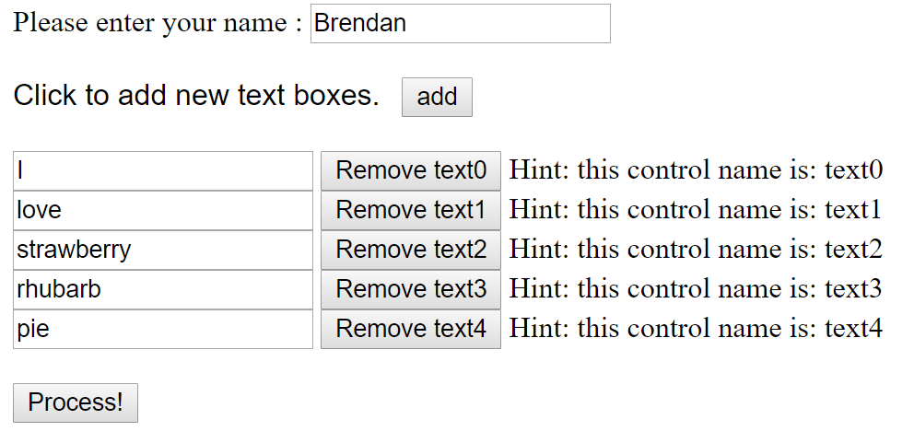

Result:

Hello **Brendan**,

The values received, in order, are:

1. I
2. love
3. pie
4. rhubarb
5. strawberry

**Hints:**

* $_POST contains whatever is received.
* We probably need a temporary array of our own to use, so that we can sort it.
* To keep track of the counter “1) 2) 3)”, we can use a for statement to print the contents of your array, or you can use a foreach with a $counter to do the same.

**Question 2 (15 pts)**

*Time you should spend on this: Less than 1 hour 20 minutes.*

Design and test a set of classes to match the following requirements:

We want to design a train control program. We will hold the elements of the train in an array in the Train class. The individual cars will be of type “Car”, and they will represent train cars.

**Information we need to record about a train car**

1. $carID

*The car ID should be automatically incremented. If we create $car1 and $car2, the $car_id for each will be 1 and 2 respectively. How to do this? Remember that a static value is assigned to the class itself and is shared among all the objects. So, we can hold a “counter” in that static value, assign the ID the counter, and increment the static counter for the next object to use. All this happens in the constructor of the class.*

1. $companyName Company name (who leases this car) (Pass this in the constructor).
2. $contents Contents (pass in constructor).

**Things we can do with a train car**

1. Print the car info, like this -> Car #1, owned by Company 1, containing Wheat. This can be done using “PrintCarInfo()” or __toString() (your choice).

**Information we need about a train**

1. $train_number (The same exact behaviour as the car, an increasing number starting at 1).

**What should a train do?**

1. Add cards with an AddCar method.
2. Return the number of cars with a CarCount() method.
3. List the cars (in their exact order) in either a table format or just a regular text list using ListCars().
4. Sort the cars contained within the train by train number with a SortAscending method. You probably want to use ksort here to sort objects within an array. See example at end.
5. Sort the cars contained within the train by train number with a SortDescending method.

Remember to:

* Create mutators and accessors for all private attributes.
* Make sure to use hinting for any function that accepts a specific array or class.

Example usage:

$c1 = new Car(“Company 1”, “Wheat”);

$c2 = new Car(“Company 2”, “Flax Seed”);

$t1 = new Train();

$t1->AddCar($c1);

$t1->AddCar($c2);

echo $t1->CarCount();

2

$t1->ListCars();

Displays something like the following:

Train ID : 1

Listing of cars as positioned in the train;

Car #1, owned by Company 1, containing Wheat.

Car #2, owned by Company 2, containing Flax Seed.

$t1->SortDescending();

$t1->ListCars();

Displays something like the following:

Train ID : 1

Listing of cars as positioned in the train;

Car #2, owned by Company 2, containing Flax Seed.

Car #1, owned by Company 1, containing Wheat.

Example sort:

function cmp($a, $b) // Sort by id

{

return strcmp($a->id, $b->id);

}

usort($your_data, "cmp");